***DAY 5***

***ASSIGNMENT***

* ***Add 10 GB to Centos and partition it in 4GB and 6 GB:***

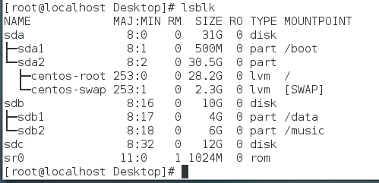

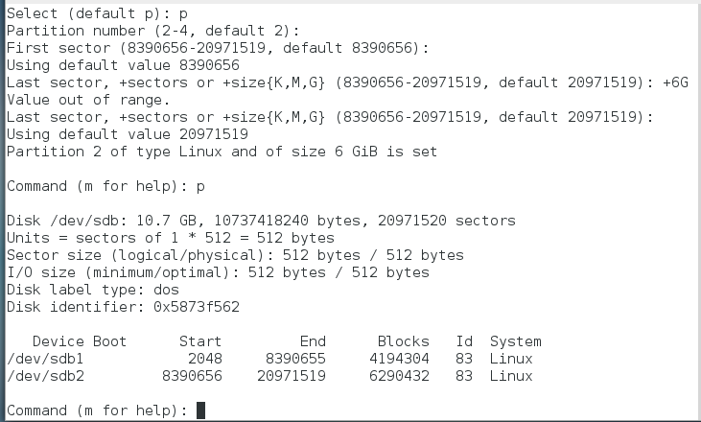

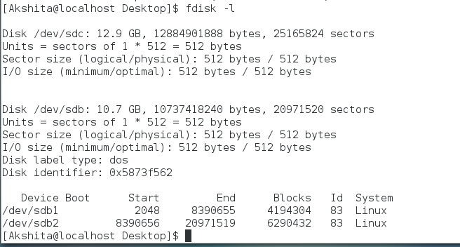

* ***Format 4 GB with .xfs and 6 GB with .ext4:***

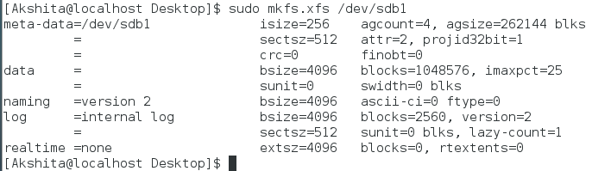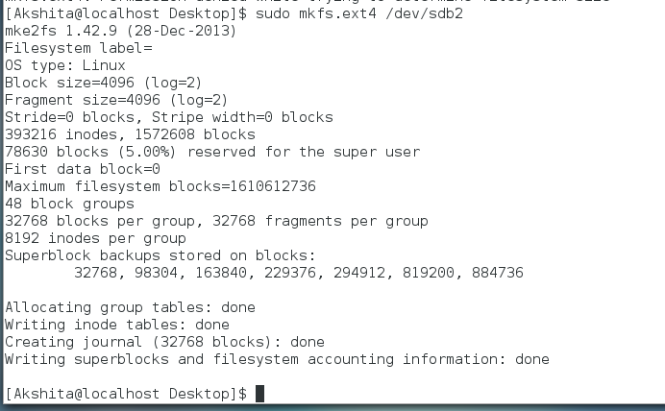

* ***Mount 4GB in /data and 6GB in /music directories respectively :***

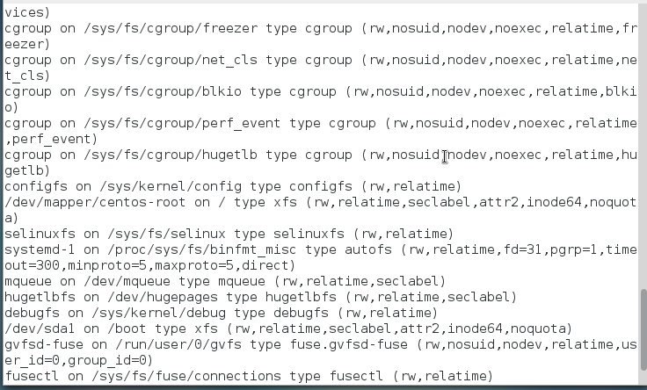

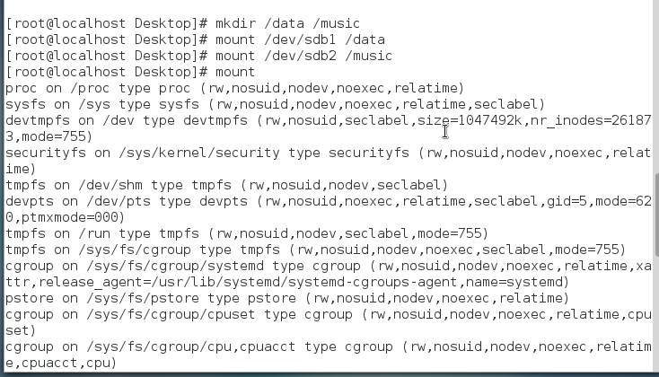

* ***Verify the disk space and disk consumption in the mounted partitions:***

